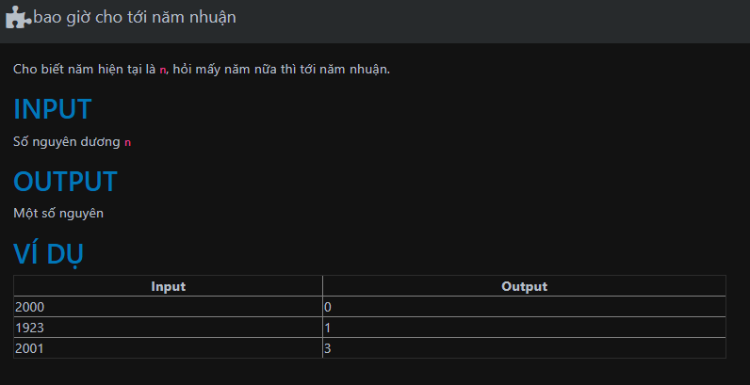

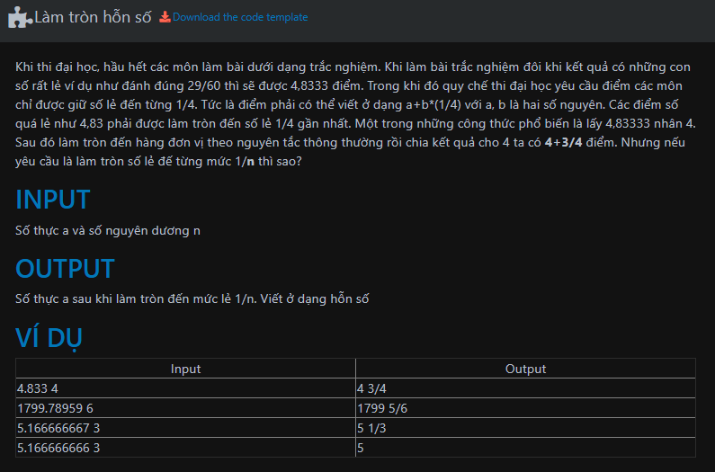

/\*###Begin banned keyword - each of the following line if appear in code will raise error. regex supported

define

include

class

###End banned keyword\*/

#include <iostream>

int main()

{

double a;

int n;

std::cin >> a >> n;

//###INSERT CODE HERE -

}

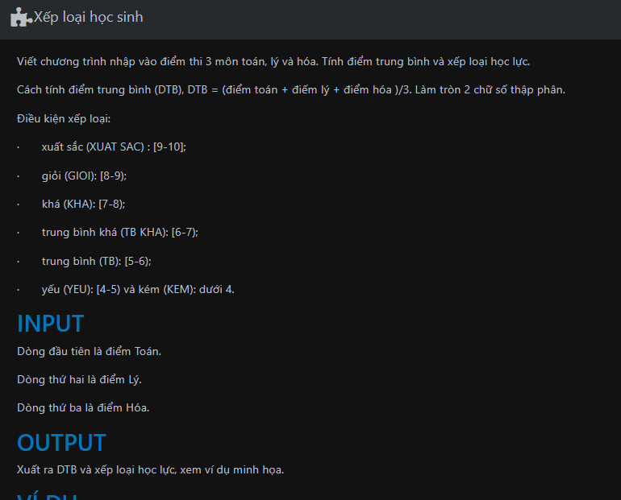

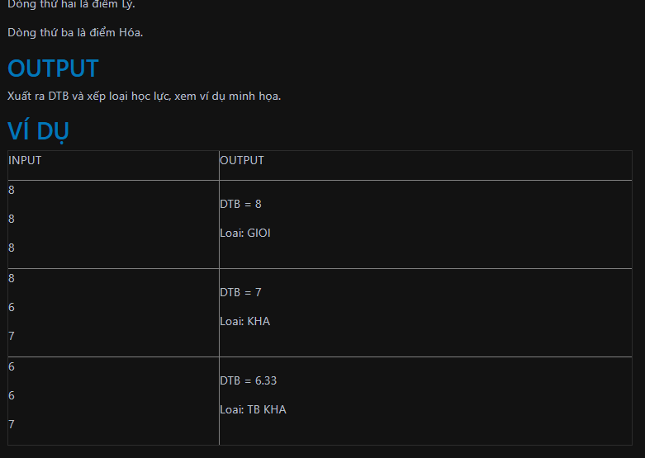

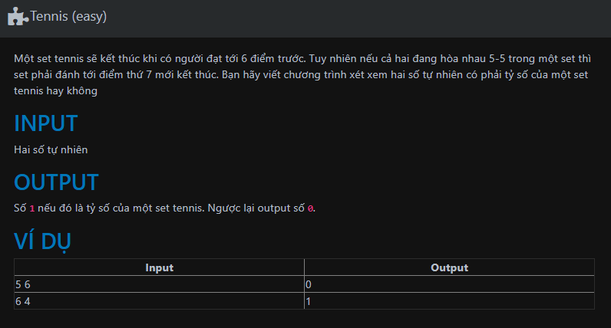

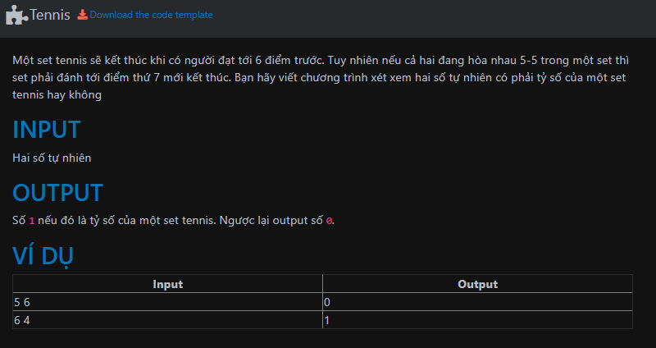

/\*###Begin banned keyword - each of the following line if appear in code will raise error. regex supported

define

include

using

if

switch

;

?

###End banned keyword\*/

#include <iostream>

int main () {

unsigned int a, b;

std::cin >> a >> b ;

std::cout <<

//###INSERT CODE HERE -

<< std::endl

;

}

